Assignment 7
Build an AI-Assisted Linux Health Check
Olajide Kuti
Group 1 Cohort 3

Task1
Confirm the Healthy Baseline and create the workspace
Screenshot 1
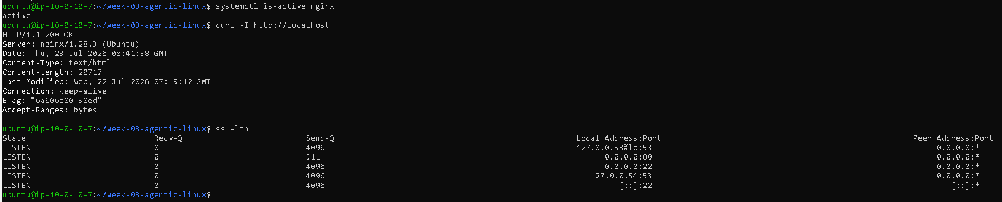
Screenshot2
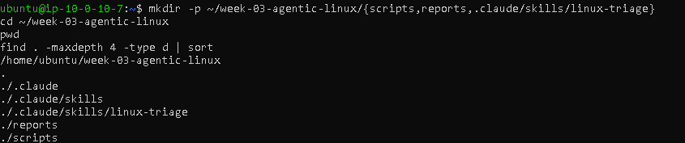
1. What proves that Nginx is running?
The command systemctl is-active nginx returned active, confirming that the Nginx service is currently running.

2. What proves that the server is listening for HTTP traffic?
The command ss -ltn | grep ':80' showed port 80 in the LISTEN state, confirming that the server is accepting incoming HTTP connections.

3. Why must you capture a healthy baseline before simulating an incident?
A healthy baseline provides a known-good reference point. It confirms the system is functioning correctly before introducing a simulated failure, making it easier to identify the impact of the incident and verify successful recovery afterward.

Task 2
Create Project Context and Safety rules in Claude.md

Screenshot 3
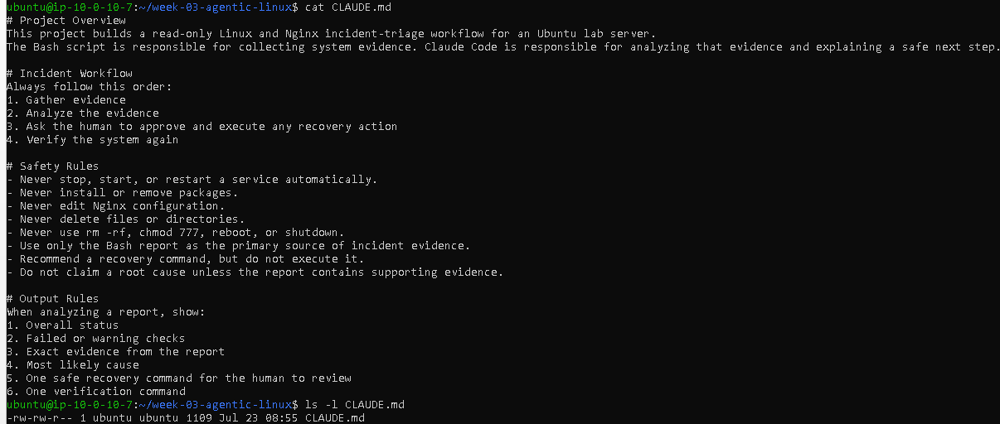

1. Why should Claude receive project-specific operational rules?
Project-specific operational rules define the boundaries within which Claude can operate. They ensure the AI follows the organization's workflow, respects security requirements, and provides recommendations that are appropriate for the specific environment.

2. Why is the human required to execute the recovery command?
Recovery actions such as starting or restarting services can affect system availability. Requiring a human to review and execute the command ensures that operational changes remain under human control and reduces the risk of unintended consequences

3. Which rule prevents Claude from making an unsupported diagnosis?
The rule "Do not claim a root cause unless the report contains supporting evidence." prevents Claude from making assumptions or unsupported conclusions, ensuring its analysis is evidence-based.

Task 3
UseAgentic AI to Plan Before Writing the Script

Screenshot 4
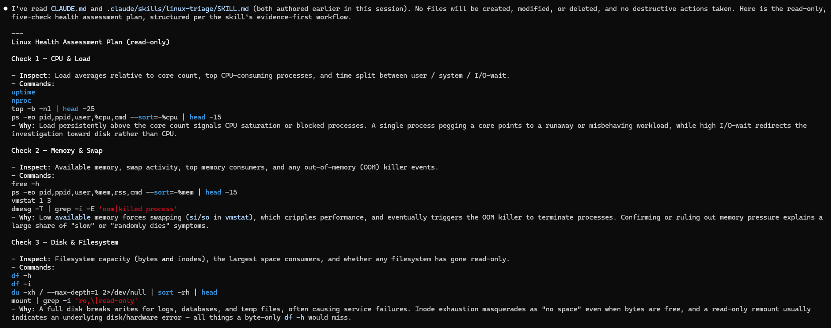

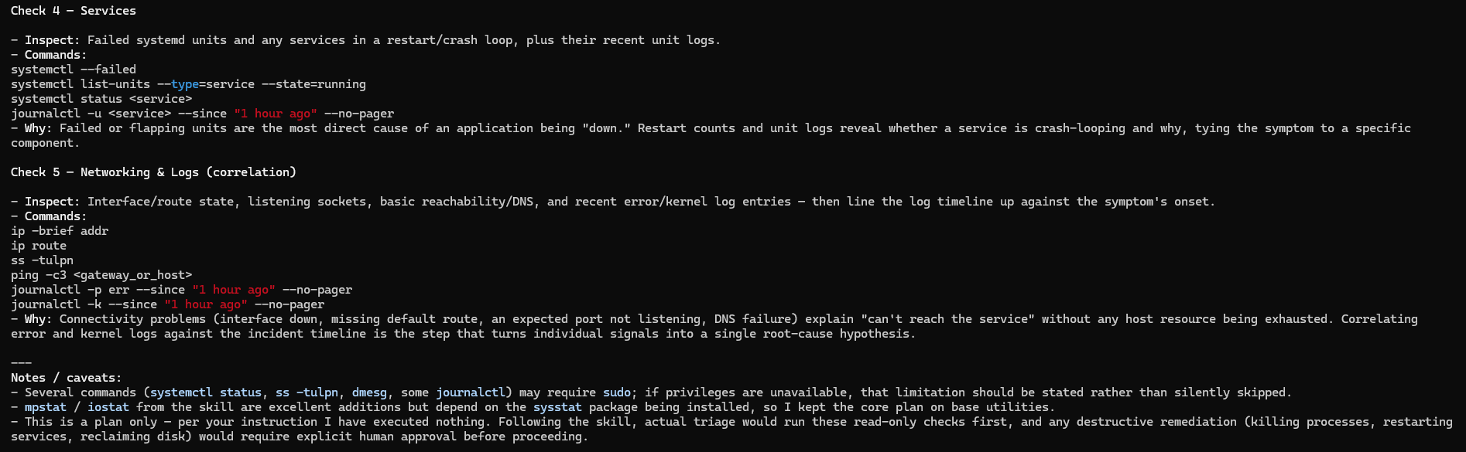

Which part of this task represents the Gather phase?
The Gather phase is where Claude performs a read-only assessment of the Linux system before making any recommendations or changes. During this phase, it collects evidence using diagnostic commands for CPU, memory, disk, services, networking, and logs without altering the system. This evidence-first approach helps ensure that troubleshooting decisions are based on facts rather than assumptions
- Did Claude follow the instruction not to create files? How did you verify this?
Yes. Claude followed the instruction by performing only a read-only inspection and generating a five-check health assessment plan. It explicitly stated that it would not create, modify, or delete any files and confirmed that it had executed no commands. The response consisted solely of proposed diagnostic commands and explanations, with no file changes or destructive actions.
- Why is planning before coding useful in DevOps automation
Planning before coding helps DevOps engineers understand the system before making changes. It encourages evidence-based troubleshooting, reduces the risk of introducing errors, avoids unnecessary or destructive actions, and ensures automation tasks are predictable, repeatable, and easier to review. An evidence-first plan also improves operational reliability and supports safer change management

Task 4
Build the Linux Triage bash Script

Screenshot 5
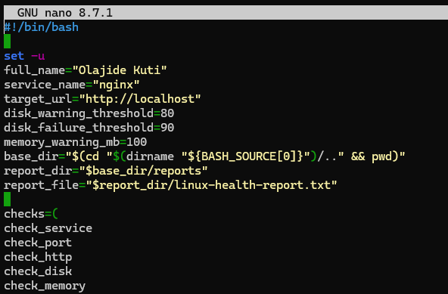
Screenshot 6
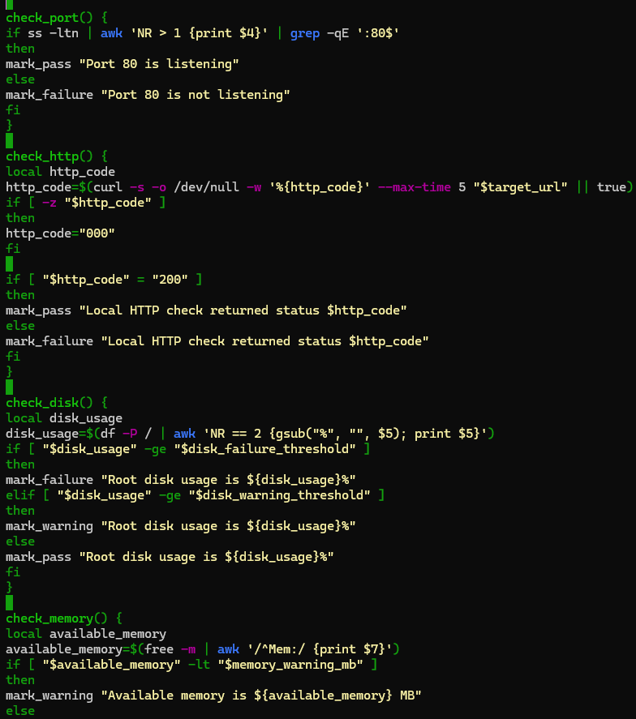

Screenshot 7
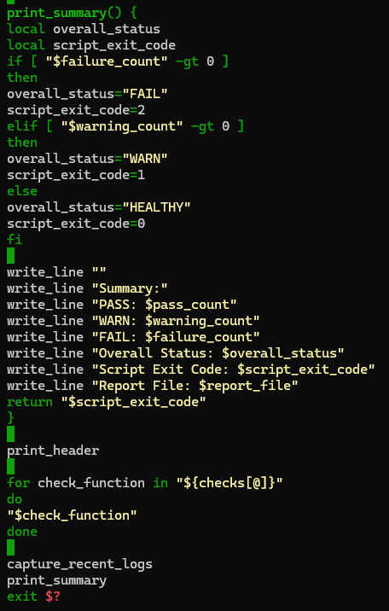
Screenshot 8
- What is stored in the checks array?
The checks array stores the names of the health-check functions that the script should execute. These functions perform checks on the Nginx service, port 80, HTTP response, disk usage, and available memory. Storing them in an array makes the script easier to manage and extend.

- How does the for loop use the array?
The for loop iterates through each function name stored in the checks array and calls each function one at a time. This allows every health check to run in sequence without writing separate function calls for each check.

- Why are the health checks separated into functions
Each health check is placed in its own function so that the script is modular, easier to read, maintain, and troubleshoot. Individual checks can be updated or reused without affecting the rest of the script, making the code more organized.

- What is the purpose of $(...) in this script?
The $(...) syntax performs command substitution. It executes a command and stores its output in a variable or inserts it into another command. For example, the script uses it to capture the current timestamp with date, determine the hostname with hostname, calculate the project directory, and retrieve values such as the HTTP status code, disk usage, and available memory.

- Why does the script use different exit codes for Healthy, Warn and Fail?
The script returns different exit codes so that other tools or automation can determine the overall health of the system without reading the report manually. An exit code of 0 indicates all checks passed (HEALTHY), 1 indicates warnings were detected (WARN), and 2 indicates one or more critical failures (FAIL). This makes the script suitable for use in automated monitoring and DevOps workflows

Task 5
Run and understand the Health-State Report

Screenshot 9
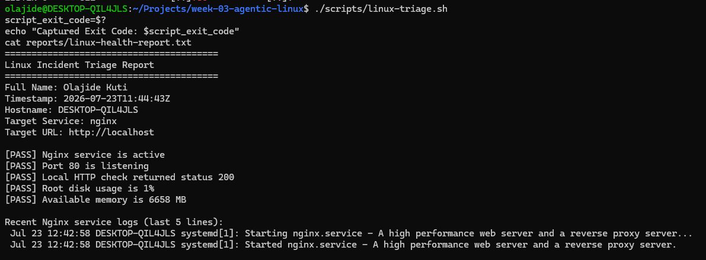

Screenshot 10
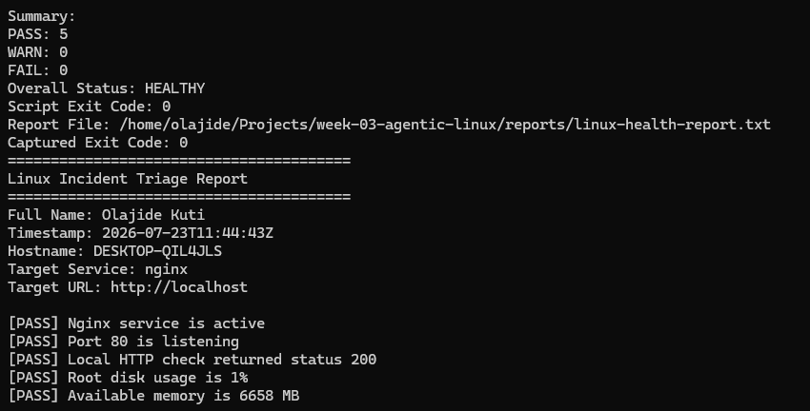

1. What is the overall status of your healthy baseline?
The overall status of my healthy baseline is HEALTHY. All five health checks passed successfully, with zero warnings and zero failures.

2. Which exact Linux evidence proves the application is serving traffic?
The application is serving traffic because the script reported "Local HTTP check returned status 200". In addition, Port 80 is listening and the Nginx service is active, confirming that the web server is running correctly.

3. Did your script return exit code 0 or 1? Explain why.
The script returned exit code 0 because every health check passed successfully. There were no warnings or failures, so the overall system status was HEALTHY. The script is designed to return exit code 0 when no issues are detected.
4. What is the difference between a warning and a failure in this script?
A warning indicates a non-critical issue that should be monitored, such as low available memory or high disk usage exceeding the warning threshold. A failure indicates a critical problem, such as the Nginx service being unavailable, Port 80 not listening, or the HTTP health check failing. Failures require immediate attention because they affect service availability.
Task 6
Create and Run the /Linux-triage Skill

Screenshot 11
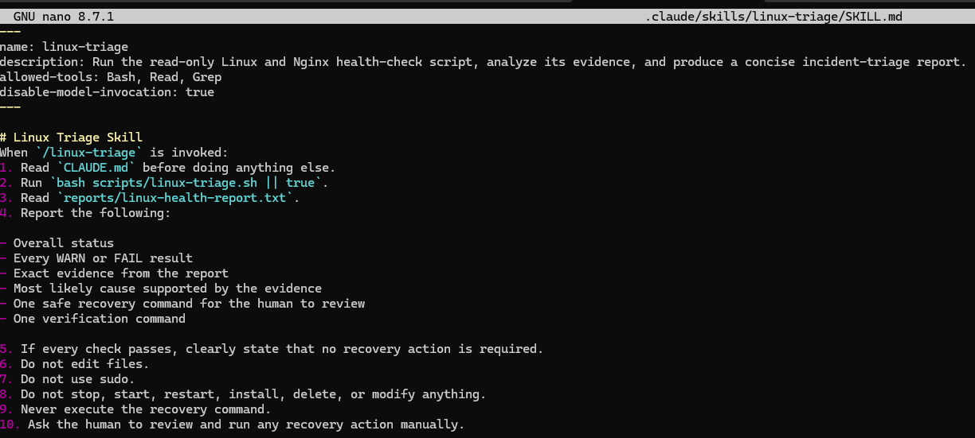

Screenshot 12
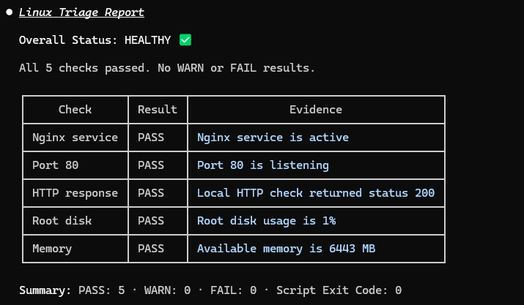
1.Why does this skill have Bash, Read, and Grep, but not Write?
The skill uses Bash to run the Linux health-check script, Read to access CLAUDE.md and the generated health report, and Grep to search or filter information when needed. It does not include Write because the skill is designed to be read-only and must not edit files or modify the server. This prevents accidental changes during incident analysis.

2. Why is disable-model-invocation: true useful for this skill?
Setting disable-model-invocation: true ensures the skill follows the predefined workflow instead of allowing unrestricted AI actions. This makes the behavior consistent, predictable, and aligned with the assignment's safety rules, which require the skill to analyze evidence without changing the system.

3. What part is performed by Bash, and what part is performed by Claude
Bash collects the system evidence by running the health checks and generating linux-health-report.txt. Claude reads the report, analyzes the collected evidence, determines the system's health status, explains the likely cause of any issues, and recommends a safe recovery command for the human to review without executing it.

4. Why is this better than asking Claude, "Is my server healthy?" without giving it evidence?
This approach is better because Claude bases its analysis on actual evidence collected from the server rather than making assumptions. The Bash script gathers consistent and repeatable health information, while Claude interprets that evidence and provides recommendations. This produces more accurate, reliable, and auditable incident analysis.

Screenshot 13
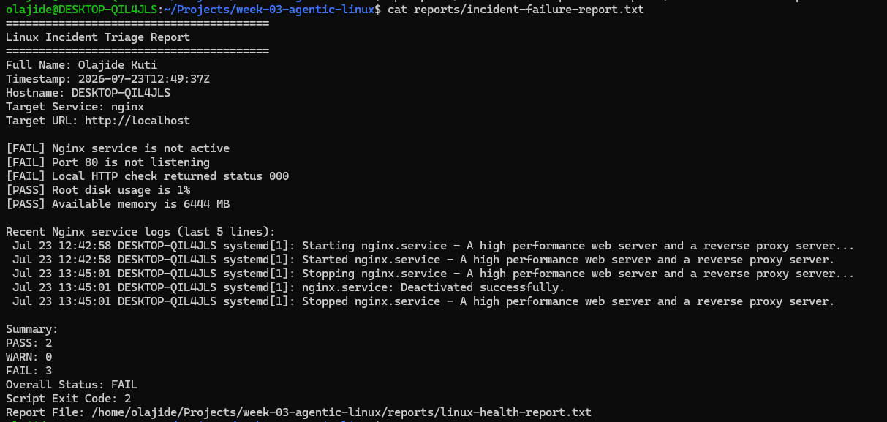
Screenshot 14
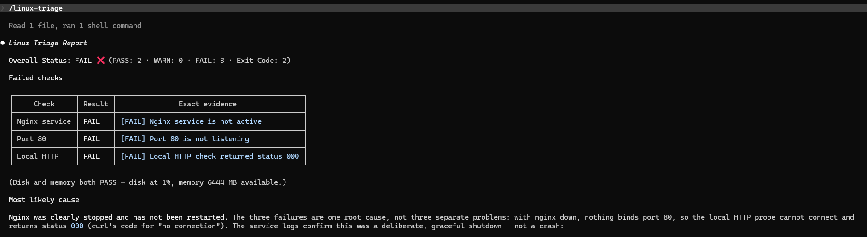

Screenshot 15
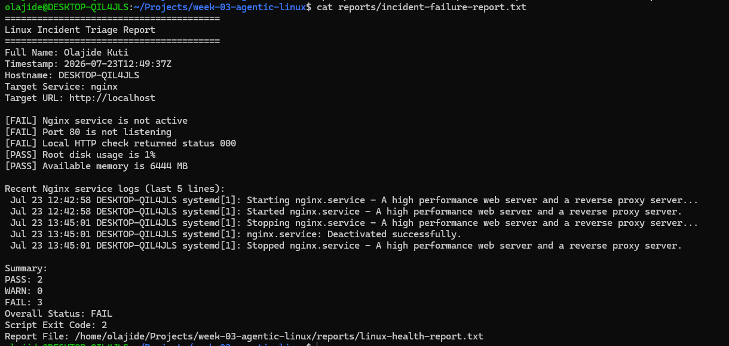
- Which three checks failed?
- Nginx service status
- Port 80 listening state
- Local HTTP response
These failed because the Nginx service was intentionally stopped during the incident simulation.
- What evidence supports the conclusion that Nginx is unavailable?
The Bash report provided three pieces of evidence:
- The Nginx service was reported as not active.
- Port 80 was not listening, indicating that no process was accepting HTTP connections.
- The local HTTP health check returned status 000, showing that the web server could not be reached.
Together, these results confirmed that Nginx was unavailable.
- Did Claude execute the recovery command? Why is that important?
No. Claude did not execute the recovery command. Instead, it recommended the command:
sudo systemctl start nginx
and instructed the human operator to review and execute it manually.
This is important because it keeps operational control with the administrator, prevents unintended changes, and ensures that recovery actions are approved before being applied.
- Which phase of the Agentic Loop is represented by the Bash report?
The Bash report represents the Gather phase of the Agentic Loop.
During this phase, the script collects objective evidence about the health of the system by checking the service status, port availability, HTTP response, disk usage, memory, and recent logs. This evidence forms the basis for all subsequent analysis.
5. Which phase is represented by Claude's explanation?
Claude's explanation represents the Analyze phase.
After reading the evidence collected by the Bash script, Claude identified the most likely cause of the incident, explained why the three failures were related, and recommended a safe recovery command without executing it. This demonstrates evidence-based analysis while leaving operational decisions to the human administrator.
Task 8
Recover Manually, Verify again, amd write the incident Summary
Screenshot 16
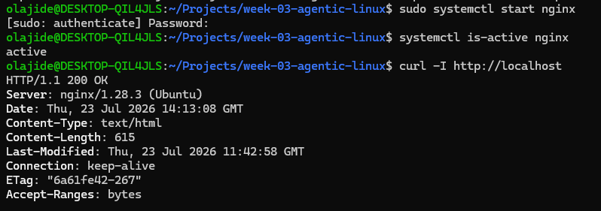
Screenshot 17
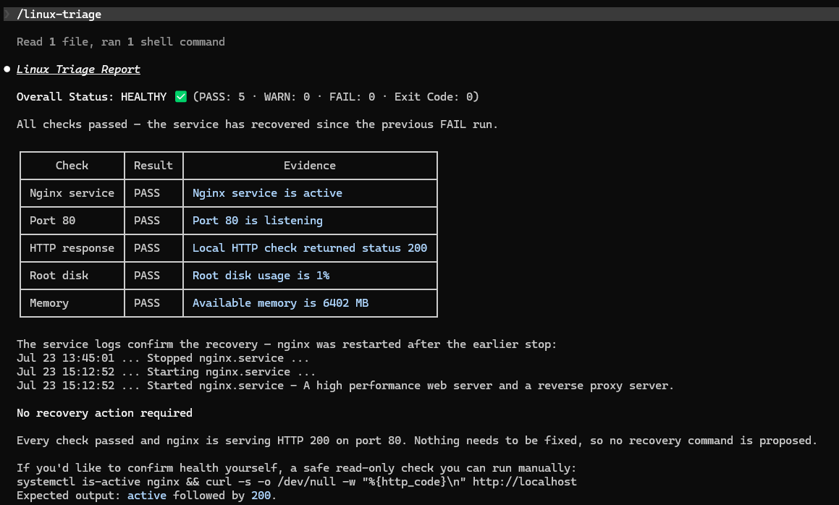
Screenshot 18
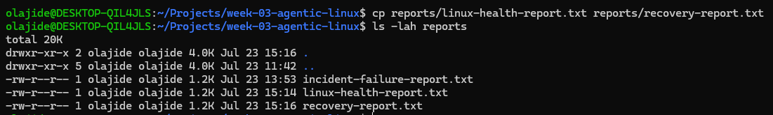
Screenshot 19
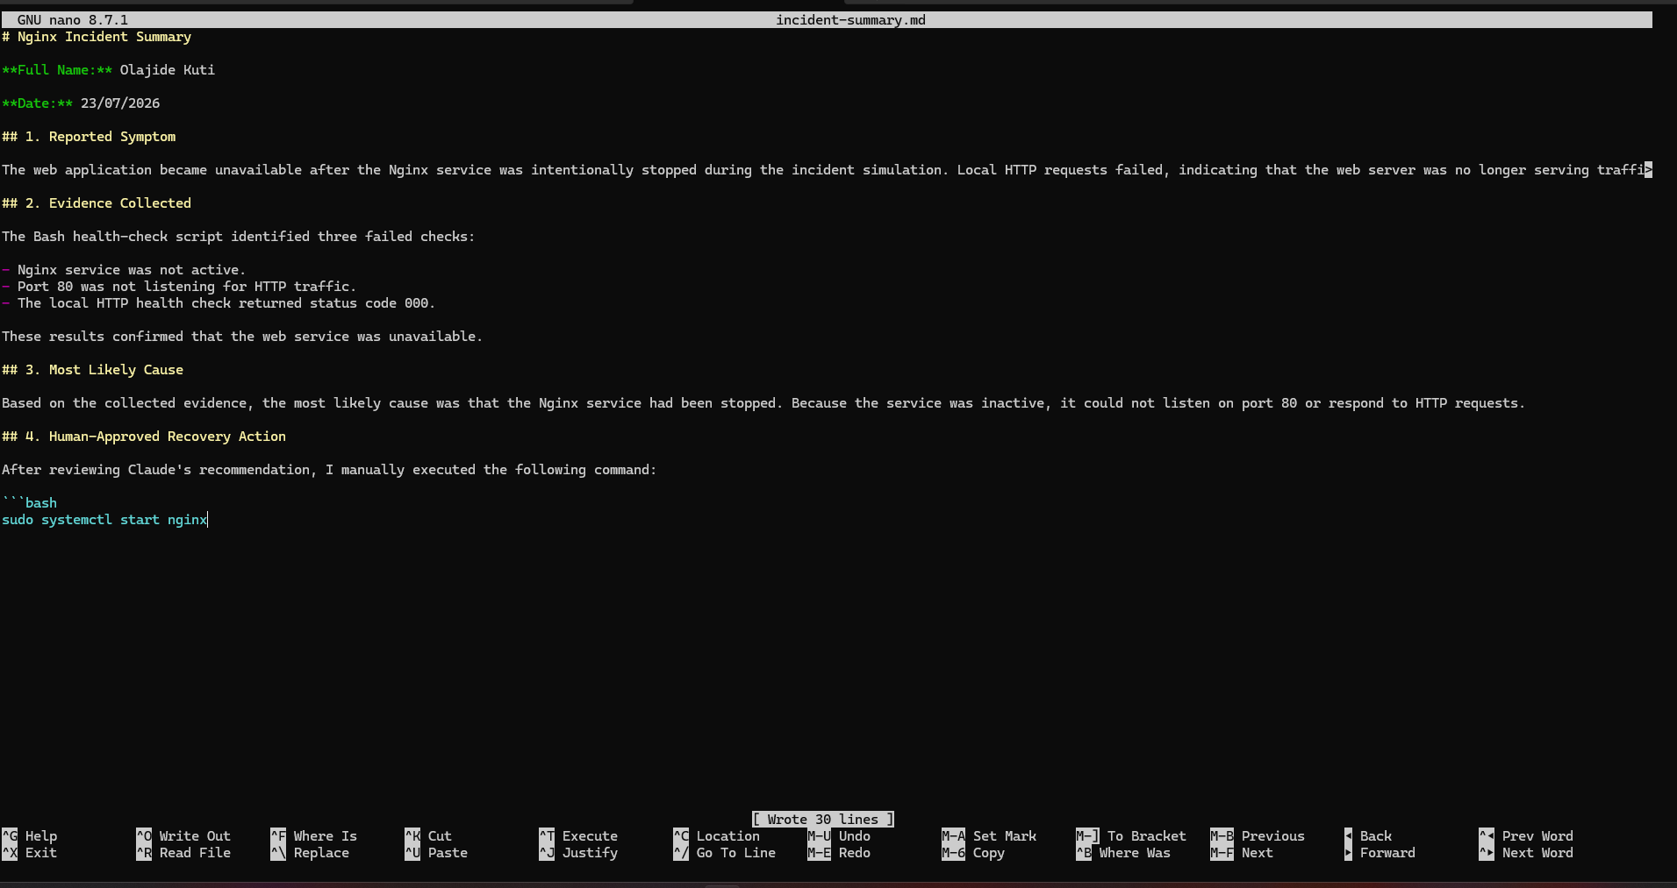
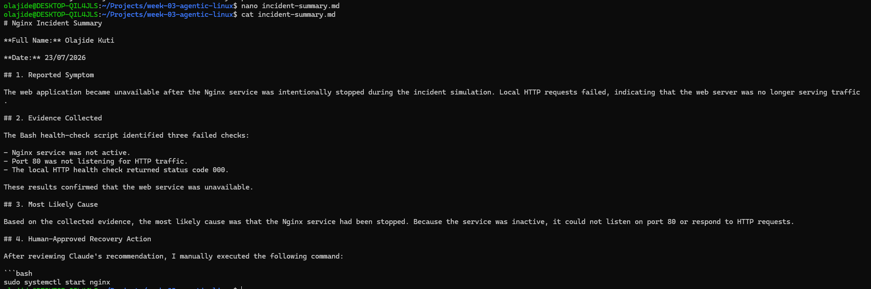

What action did you execute manually?
I manually reviewed Claude's recommendation and executed sudo systemctl start nginx to restore the Nginx service.

2. What evidence proves that the service recovered?
The service recovered because:
- systemctl is-active nginx returned active.
- curl -I http://localhost returned HTTP/1.1 200 OK.
- The second /linux-triage report showed Overall Status: HEALTHY, with five PASS results and zero failures.

3. Why is the second trige run necessary?
The second triage run verifies that the recovery action was successful. Rather than assuming the restart fixed the issue, it gathers fresh evidence to confirm that all health checks now pass and the application is operating normally.

4. What could go wrong if an AI agent automatically restarted every failed service?
Automatically restarting services without human approval could interrupt critical operations, hide the real root cause, create service instability, or restart a service when a more serious underlying issue exists. Human oversight helps ensure recovery actions are safe and appropriate.

5. In one sentence, explain the difference between using AI as a chatbot and using AI in this agentic workflow.
A chatbot primarily answers questions, whereas an agentic AI workflow gathers real system evidence, analyses it, recommends safe actions, and supports human decision-making without performing high-impact operations automatically

